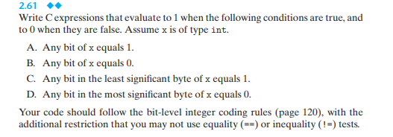

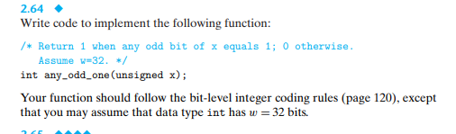

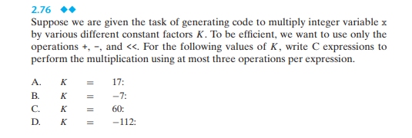

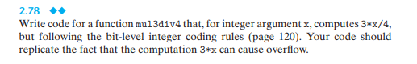

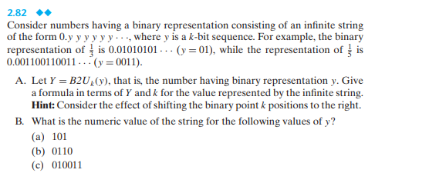

Answers:
2.61:
#include <stdio.h>
static void printresponse(char *res) {

printf("%s\n", res);

}

//Condition A: Any bit of x equals 1.

int CondA(int x) {

return !!x;

}

//Condition B: Any bit of x equals 0.

int CondB(int x) {

return !x;
}

//Condition C: Any bit in the least significant byte of x equals 1

int CondC(int x) {

return !!(x & 0xFF);

}

//Condition D: Any bit in the most significant byte of x equals 0.

int CondD(int x) {

return !!(~x & 0xFF);

}

//main

int main(void) {

//Part where we set the integer below.
int inp = sizeof(int) << 3;

//Test values to declare
int onebitequals1 = ~0;
int onebitequals0 = 0;
int onebitatleast1 = 0xFF;
int onebitatmost0 = 0xFF << (inp - 1);

//Output Display Below
printf("Assignment 2.61\n");
printf("C Expression Conditions\n");
printf("Date:9/14/2021\n");

//Should print message saying Statement A is true if any bit of x is equal to 1.
(CondA(onebitequals1)) && (printf("Condition A is True\n"));

//Should print message saying Statement B is true if any bit of x is equal to 0.
(CondB(onebitequals0)) && (printf("Condition B is True\12"));

//Should print message saying Statement C is true if the least significant bit is 1.
(CondC(onebitatleast1)) && (printf("Condition C is True\n"));

//Should print message saying return true if most significant bit is 0
(CondD(onebitatmost0)) && (printf("Condition D is True\n"));

getchar();

return 0;
}

2.64:
#include <stdio.h>

int any_odd_one(unsigned x) {

//0x55555555 represent that even number is 0, and odd number is 1.Should be the one to use for this question.
//0xAAAAAAAA represents even number 1 and odd being 0.

return (x & 0x55555555) != 0;
}

int main() {

unsigned o;

printf("Problem 2.64\n");
printf("Assignment:Any Odd One\n");
// User inserts a number and the result would show 1 indicating x equals 1 or 0 indicating x does not equal 1.

printf("Please enter a number: ");

scanf("%u",&o);
printf("Output: %d\n",any_odd_one(o));
}
2.76:
A.
K = 17
K = 16+1
X*K = X*(16) + X
X*K = (X << 4) + X
C Expression:
X = (X << 4) + X
B.
K = -7
K = 1 – 8
X*K = X – X*8
X*K = X – (X<<3)
C Expression:
X = X – (X<< 3)
C.
K = 64 – 4
X*K = X*64 – X*4
X*K = (X << 6) – (X << 2)
C Expression:
X = (X << 6) – (X << 2)
D.
K = -112
K = 16 – 128
X*K = (X << 4) – (X << 7)
C Expression:
X = (X << 4) – (X << 7)

2.78:
#include <stdio.h>
// Need to create a function that computes 3*x/4 and follows the bit-level integer rule.

int mul3div4(int x) {
return ((x << 1) + x) >> 2;
}

int main() {
int x;

// Should Display an option to put a number that is for x and the results appearing below.
printf("Assignment 2.78: MUL3DIV4\n");

printf("Please insert a number:");

scanf("%d" , &x);
//Should display a number after inserting one.
printf("Output:%d\n" , mul3div4(x));

return 0;
}
2.82:
A.
y = B$2U_{k\left(y\right)}$
B$2U_{k\left(01\right)}=1$ and B$2U_{k\left(0011\right)}=3$
K = 2 and k=4
Next we find the x value
X * $2^{k}$ = y+x
X($2^{k}-1$) = y
Answer: X= $\frac{y}{2^{k}-1}$
B.
(b1). 101 k=3, y=5
X = $\frac{5}{2^{3}-1}$ = $\frac{5}{7}$
Answer: $\frac{5}{7}$
(b2). 0110 k=4, y =6
X = $\frac{6}{2^{4}-1}= \frac{6}{15}$ = $\frac{2}{5}$
Answer: $\frac{2}{5}$
(b3). 010011 k=6, y= 19
X = $\frac{19}{2^{6}-1}$ = $\frac{19}{63}$
Answer: $\frac{19}{63}$

